**Lab Exercises:**

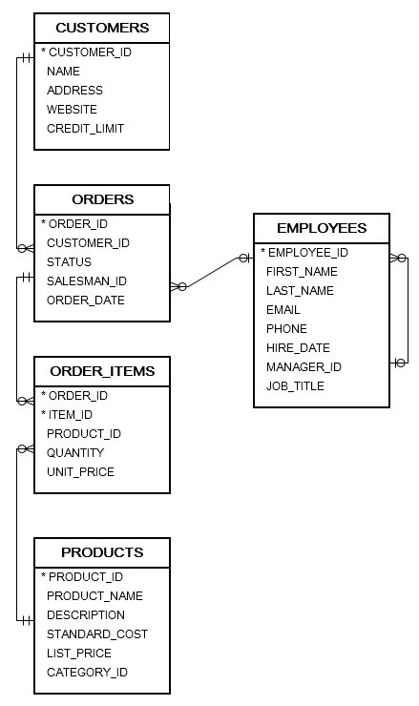

**Part I: DML:**

1. Insert the following data to **Customers** table.

|  |  |  |  |
| --- | --- | --- | --- |
| Customer_ID | Name | Address | Credit_limit |
| 320 | Samer | Amman | 100 |
| 321 | Ahmad | Aqaba | 200 |
| 322 | Ali | Amman | 300 |

1. Update the **Customers** address to ‘Salt’ for all customers who lives in Aqaba.
2. Update the credit limit for the customers by adding 200 on the current credit limit for all customers who lives in Amman.
3. Commit your transactions.

**Part II: Sequences:**

* + - 1. Create a sequence products_Seq that starts with 300, with maximum value of 1000 and incremented by 1.
      2. Insert a new record in products table, with the data as follows and use the sequence to create a product ID.

|  |  |  |  |
| --- | --- | --- | --- |
| product_ID | Product_name | List_price | category |
| Use products_Seq | Ram | 20 | 1 |
| Use products_Seq | CPU | 100 | 2 |
| Use products_Seq | Mouse | 5 | 3 |

* + - 1. Commit your transactions.
      2. Retrieve the current value of the sequence products_Seq.

**Part III: Views:**

1. Create a view for the orders table called view_orders that contains the order_id, customer_id, status, order_date. Name the columns as following orderID, customerID, status, orderDate for orders which status is ‘Pending’. Use “WITH CHECK OPTION”.
2. Insert a new order with id = 106, customer_id=318,status=’Pending’, order_date=sysdate to the view.
3. Recreate the view with “WITH READ ONLY”
4. Create a new view for the order_items, products table called view_items that contains the order_id, product_id, quantity, unit_price, product_name, list_price. Name the columns as following orderID, productID, quantity, Price, product, list_price